Chapter 6, Solution 74.

RC = 0.01 x 20 x 10⁻³ sec

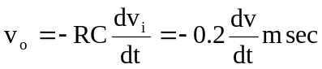

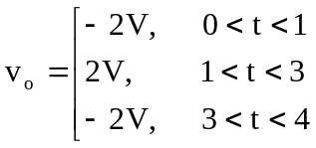

Thus v_{o}(t) is as sketched below:
v_{o}(t) (V)
-2
1
2
2
t (ms)
3

